APX7000
Dual Display

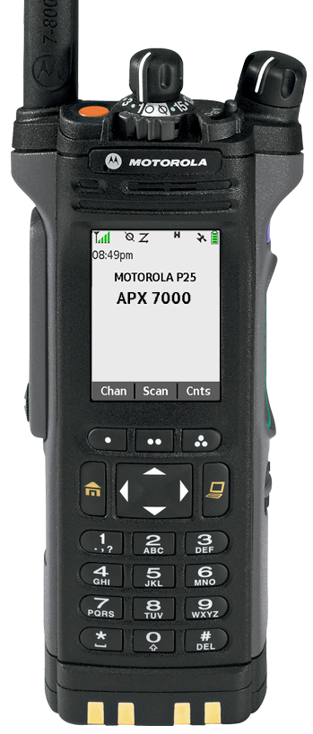



Scan On/Off - Top Side Button
- Press and release the Top Side Button to turn scan on or off.
You see the current scan state – SCAN ON or SCAN OFF. The scan status symbol is displayed, indicating scan is active.
Edit the Scan List - Menu
- Press the right side of the 4-way navigation button until SCLN is displayed.
- Press and release the menu button below SCNL.
- Programming icon appears on the display.
- Select the Zone by depressing the right or left navigation button and the 16 button select knob to select the channel to be scanned.
- Press the button directly below SEL or DEL or RCL.
- Repeat steps for each channel to be scanned
- Press the HOME button to exit editing Scan List.
Keypad Tones Mute/Unmute (Menu)
- Press the button directly below MUTE.
The current state is shown – TONES OFF or TONES ON.
- Press the button directly below OFF or ON.
Note: Press the Home or the PTT button to exit without changing the setting. Turning off keypad tones does not affect any other tones.

Keypad Lock/Unlock – 2-Position Concentric Switch
Keypad Lock – Move 2-Position Concentric Switch to .
Keypad Unlock - Move 2-Position Concentric Switch to O.

Quick
Reference
Card
Tones Chart
Symptom | Possible Cause/Solution
Busy Tones  A Group of Low-Pitched  Tones | You cannot transmit because all channels are busy, release PTT and wait for call-back.
Three short high pitched tones | Talk Permit. You can now continue with your requested transmission.
Continuous low-pitched tone when pressing the PTT button | Indicates you are out of range, or the Time-Out Timer has activated. May also indicate an Invalid Mode, or Talk Prohibit/PTT Inhibit.

Backlight and  Bar Color | Notification | When
Orange | Emergency Alerts | The radio initiates an emergency alarm or call.
Orange | Emergency Alerts | The radio receives an  emergency alarm or call.
Red | Critical Alerts | The radio is out of range.
Red | Critical Alerts | The radio enters failsoft  mode.
Red | Critical Alerts | The radio is unable to establish a full connection with the system.
Green | Call Alerts | The radio receives a private call.
Green | Call Alerts | The radio receives a call alert.


Turn Radio On/Off  - Turn the radio on by rotating the On/Off/Volume Control Knob clockwise until you hear a click.  - Turn the radio off by rotating the On/Off/Volume Control Knob counterclockwise until you hear a click.  Select a Channel  - Rotate the 16-position Channel select knob to the desired Channel. The new channel name will appear on the display.  - Press the PTT button to transmit. When speaking, keep the microphone 1-2” from your mouth.  - Release PTT button to listen.  Select a Zone - Menu  - Press the right side of the 4-way navigation button until ZONE is displayed.  - Press the right side of the 4-way navigation button until the desired zone is displayed.  - Press the Home button to confirm the displayed Zone.  Select a Zone – Side Button 1 or 2  - Press Side button 1 to Zone Up or Side button 2 to Zone Down.  Emergency – Trunked Feature (Top Orange Button)  - With the radio turned on, press the emergency button.  The LED lights solid red, the display alternates between showing “EMERGENCY” and the current trunked zone and talkgroup/channel, and a short, medium-pitched emergency tone sounds.  2. Press the PTT button and announce your emergency.  3. Release the PTT button to end the transmission and wait for a response from the dispatcher.  - To exit emergency: Press and hold the Emergency button for about one second.  The radio user should NEVER clear the emergency on their radio without being instructed to do so by dispatch. | Mode Select -Saving a Zone and Channel  to keypad  Save a zone and channel to a keypad digit.  Procedure:  1. Toggle your zone and channel to the  required zone and channel.  2. Press and hold (long press) the keypad  digit button you desire to program.  You hear a short, medium-pitched  tone when the zone and channel is saved.  To switch the radio to the programmed Zone  and Channel:  - Press and release (short press) the keypad  digit.  Respond to a Private Conversation Call  When a Private Conversation Call is received,  two alert tones are heard, the LED blinks green,  the Call Received symbol () flashes, and “CALL RECEIVD” is displayed and menu select item will automatically display RESP.  - Press the menu select button below RESP  button within 20 seconds after the call  indicators begin.  - Press and hold the PTT button to talk.  Release the PTT button to listen.  - Press the Home to hang up and return to  the Home screen.  Respond to a Call Alert Page  When you receive a call alert page you hear  four repeating alert tones and the LED blinks  green. The call received icon blinks and display  shows “PAGE RECEIVED”.  - Press PTT or any button to clear the page.

Top View
APX7000 Controls
Initiate/Cancel an Emergency Alarm
- To initiate an alarm, press the Emergency button. An alert tone (beep) sounds and the display alternates between EMERGENCY and the selected talkgroup and the emergency is transmitted.
- A single beep indicates acknowledgement by the central controller (not necessarily the dispatcher).
- After a dispatcher acknowledgement the radio will beep 4 times and the display will read ACK RECEIVED.
- To cancel an alarm, press and hold the Emergency button until you hear a continuous exit tone.
View Your ID Number
- Press the Call or Page button.
- Press the Mode Select button (backward once) to display “MY ID: ######” with the unit’s ID number.
- You can also press the “*” button to quickly display the radio’s ID number.
- Press the Call or Home button to exit.
* Buttons may be redefined in programming. Refer to your specific radio program. Print Date: 07/29/26

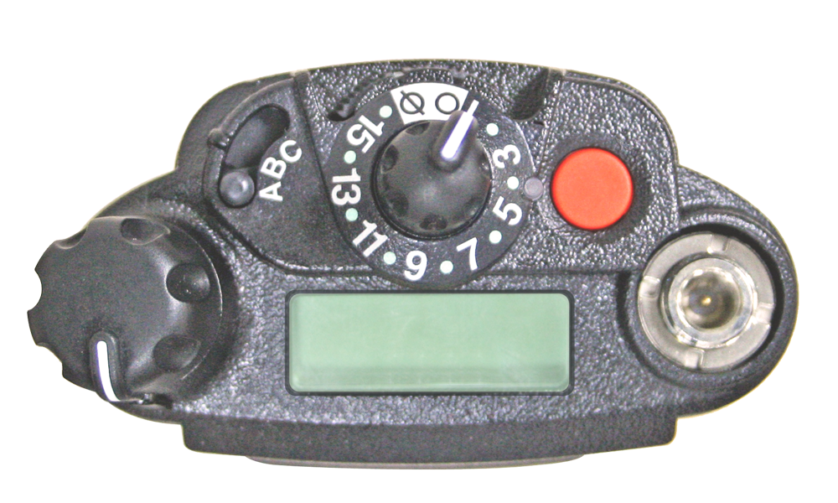
16-Position
Select Knob
Emergency
3-Position A/B/C
Not Programmed
On/Off/Volume
Control Knob
2-Position Concentric
Keypad Lock/Unlock

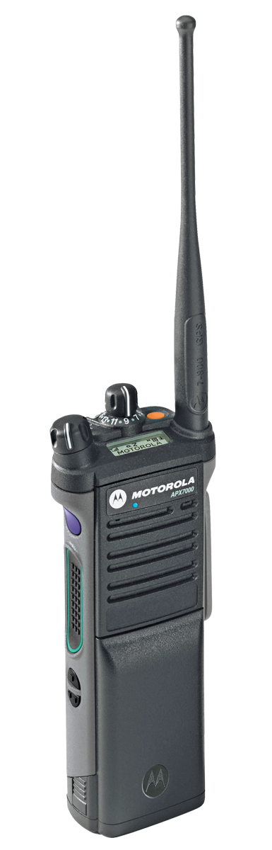
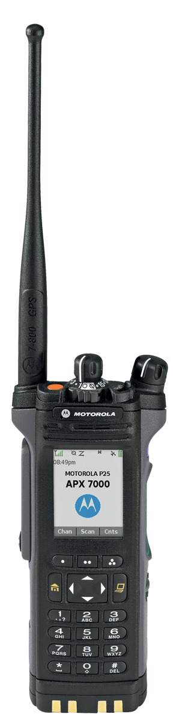
Push-to-Talk
(PTT) Button
Side Button 1
Zone Up
Side Button 2
Zone Down
Top Side Button
Scan On/Off
Top Display
Menu Select
Buttons

Side View
Menu Select Items
Nuis Prfl Zone
ScnL Mute Batt
Info Rcnt Cnts
Myid

