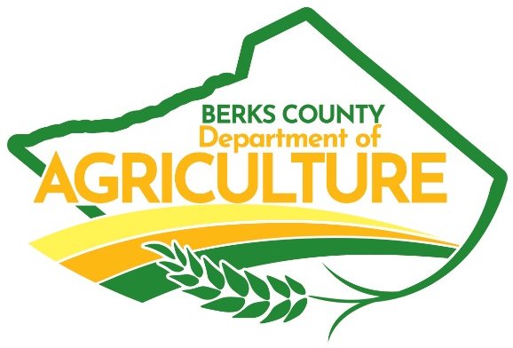

Ag in the Classroom | June 25 – 26, 2025
Educator Resources

General Resources
My American Farm | http://www.myamericanfarm.org/
Great website the connects agriculture with math, English, grammar, and many other school subjects. Gives real life math examples while learning about agriculture.
National Agriculture in the Classroom website | https://agclassroom.org/matrix/
An excellent website with hundreds of lesson plans and companion resources for agriculture and food systems activities and projects. The lesson plan list is searchable by grade and topic. This should be your first stop for classroom ag activities.
PA branch of the Farm Bureau for agricultural education in the classroom | https://pfbfriends.com/
Hosted by the PA Friends of Agriculture Foundation, the website has teachers’ resources, information on the Mobile Ag Lab, Ag Literacy Week, continuing education opportunities, ag lesson of the week, and much more!
FFA (Future Farmers of America) | https://www.ffa.org/
FFA is a dynamic youth organization that changes lives and prepares members for premier leadership, personal growth and career success through agricultural education.
4-H | https://4-h.org/
4‑H is America’s largest youth development organization—empowering nearly six million young people with the skills to lead for a lifetime. Delivered by Cooperative Extension.



Ag Careers

Pennsylvania Ag and Food Careers website | https://www.agandfoodcareersinpa.com/
Contains a lengthy list of ag and food careers and a career quiz (if students don’t know where to start).

AGCareers.com website | https://www.agcareers.com/
Agricultural job board and career resources from the US and beyond.

AGCareers.com Ag & Food Career Guide | https://www.agcareers.com/career-guide/2021/US/
Full-color, 40-page guide to finding a job in an agricultural career.

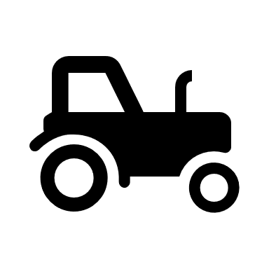
Farm Equipment
High-Tech Farming (Grades 6-8) | https://agclassroom.org/matrix/lesson/691/
Zimmerman Farm Equipment | https://www.zimmermanfarmservice.com/videos /

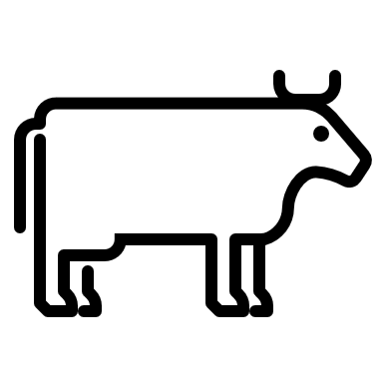

Dairy

Lesson Plans
There are 26 dairy lesson plans on the National Ag in the Classroom website. Below is a sample:
NAITC: Milk or Meat? Beef or Dairy? (Grade K-12) | https://agclassroom.org/matrix/lesson/267/
NAITC: A Day Without Dairy (Grade 3-5) | https://agclassroom.org/matrix/lesson/255/
NAITC: Cheese Making: A Science, An Art, and A Craft (Grade 6-8) | https://agclassroom.org/matrix/lesson/805/
NAITC: Lactose Lab: Some Don’t Like It Sweet (Grade 9-12) | https://agclassroom.org/matrix/lesson/269/

Websites
Adopt a Cow | https://www.discoverdairy.com/adopt-a-cow/
A year-long FREE experience in your classroom, photos and stories sent to you about her life on the farm will make her “come alive” for your students!

High-Tech Farming (Grades 6-8) | https://agclassroom.org/matrix/lesson/691/

Robotic Milking Video | https://vimeo.com/241077451
Virtual Farm Tours | https://www.americandairy.com/dairy-farms/virtual-farm-tours/
Website where you can tour a farm virtually from your classroom.
Center for Dairy Excellence | https://www.centerfordairyexcellence.org/
Resources for both today’s farmers and educational resources for tomorrow’s farmers through the Dairy Educational Foundation.
Discover Dairy | https://www.discoverdairy.com/
An engaging, interactive, cross-curricular educational series that meets Common CORE Standards for Math, Science and Reading (3-5th and 6-8th grade). This is one of the websites sponsored by the Dairy Excellence Foundation.
American Dairy Association, Northeast | https://www.americandairy.com/
Dairy resources for professionals, educators, and consumers.
PA Dairy Princess | https://padairy.org/
Opportunities for leadership development and training to promote the dairy industry for young women.
Dairy Farmers of America | https://www.dfamilk.com/
A national dairy cooperative. The website has milk facts, career information, and other resources for the general public.

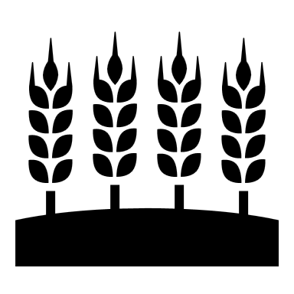

Grain & Seed
Lesson Plans
NAITC Little Red Hen | https://agclassroom.org/matrix/lesson/27/
NAITC Corn, an A-maizing Plant: Food, Fuel, and Plastic (Grade 3-5) | https://agclassroom.org/matrix/lesson/141/
NAITC FoodMASTER Middle: Grains (Grade 6-8) | https://agclassroom.org/matrix/lesson/577/
NAITC Evaluating GMO perspectives (Grade 9-12) | https://agclassroom.org/matrix/lesson/86/

Websites
Cereal & Grains Association | https://www.americanmushroom.org/
A global, nonprofit association of nearly 2,000 scientists and food industry professionals working to advance the understanding and knowledge of cereal grain science and its product development applications through research, leadership, education, technical service, and advocacy.
US Grains Council: Learn About Trade | https://grains.org/learn-about-trade/
High school level resources for learning about agricultural trade, including grains.
First the Seed Foundation | https://www.firsttheseedfoundation.org/
Aa 501(c)(3) non-profit organization established in 2008 by the American Seed Trade Association, one of the oldest trade associations in America, that informs today’s consumers and tomorrow’s workforce about the importance of the seed industry.


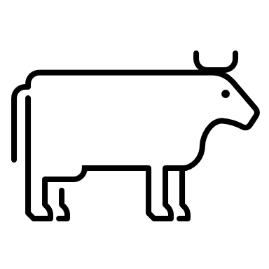
Beef
Lesson Plans
NAITC Milk or Meat? Beef or Dairy? (Grade K-2) |https://agclassroom.org/matrix/lesson/267/
NAITC Beef Basics (Grade 3-5) | https://agclassroom.org/matrix/lesson/284/
NAITC The Remarkable Ruminant (Grade 6-8) | https://agclassroom.org/matrix/lesson/604/
NAITC A Tale of Two Burgers: Beef and Plant-based Protein (Grade 9-12) | https://agclassroom.org/matrix/lesson/722/
Websites
The Pennsylvania Cattlemen's Association | https://www.pacattlemen.org/
The Pennsylvania Cattlemen's Association’s mission is to be a member driven voice to protect and preserve the Pennsylvania cattle industry through legislation, producer education and youth development.
Cattlemen's Beef Board And National Cattlemen's Beef Association | https://www.beefitswhatsfordinner.com/
Great resource for anything beef including tons of recipes and outreach brochures
**Pennsylvania Beef Council Youth Toolkit 2023-24| https://www.pa-bqa.org/resources/youth-toolkit
The Youth Toolkit serves as a free BQA certification course for your classroom. It is customizable, with hands-on activities to meet your lesson plan requirements; one day or extended time for your beef lesson!
Beef Excellence | https://www.beefexcellence.com/
The Center for Beef Excellence is a non-profit organization. CBE seeks to partner with others in the beef industry to achieve our vision


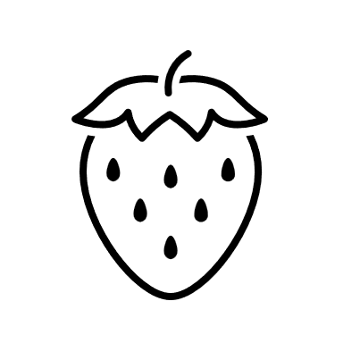
Orchards and Fruit
Lesson Plans
NAITC: A is for Apples (grades K-2) | https://agclassroom.org/matrix/lesson/374/
NAITC: Peaches What’s all the Fuzz About? Grades 3-5) | https://agclassroom.org/matrix/lesson/790/
NAITC: Walnuts Naturally Nutritious (Grades 6-8) | https://agclassroom.org/matrix/lesson/309/

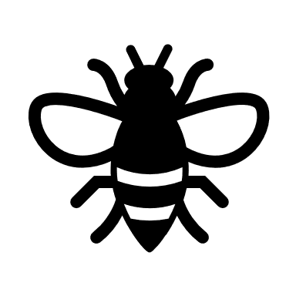

Bees and Pollinators

NAITC: The Amazing Honey Bee (Grades K-2) | https://agclassroom.org/matrix/lesson/686/
NAITC: Flower Power (Grades 6-8) | https://agclassroom.org/matrix/lesson/542/
NAITC: Preservation Power of Honey (Grades 9-12)| https://agclassroom.org/matrix/lesson/509/

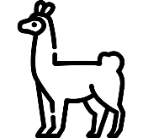
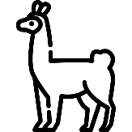
Llamas

Websites
Pennsylvania Llama and Alpaca Association | https://plaaonline.org/
A primary purpose of the organization is to promote awareness of camelids. It also serves to educate the membership and provides opportunities for various camelid activities, socializing and supporting new llama owners.
Llama Association of North America | https://www.lanainfo.org/
The premier professional association for the U.S. cultivated mushroom industry. Includes resources and careers in mushrooms.
Alpaca Llama Show Association | http://www.alsashow.net/index.html
Information, event calendar, and rules for llama and alpaca showing



Mushrooms

Lesson Plans
NAITC Fungi Multiplication (Grade 6-8) | https://agclassroom.org/matrix/lesson/624/
NAIT Pizza Time! (Grade 3-5) | https://agclassroom.org/matrix/lesson/228/

Websites
American Mushroom Institute | https://www.americanmushroom.org/
The premier professional association for the U.S. cultivated mushroom industry. Includes resources and careers in mushrooms.
East Penn Mushroomers | http://epennmushroomers.org/
EPM is a mushroom foraging club sponsoring forays, education, and collaboration.

Classroom mushroom growing kits
Amazon: Back to the Roots Organic Mushroom Growing Kit | Link
$19.39 (Prices subject to change.)
Amazon: Growing kits for Shitaake log, Lions Mane and others | Link
$27.99 and up, depending on variety (prices subject to change).
Mushroom Growing Kits Guide | https://soilcrust.org/gardening/growing/best-mushroom-growing-kits/
Overview of mushroom growing kits, and some tips on mushroom growing.

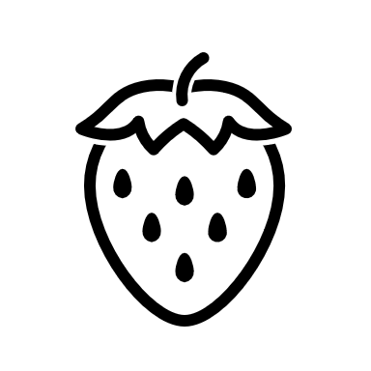

Produce

Lesson Plans
Plant Tops & Bottoms (Grade K-2) | https://agclassroom.org/matrix/lesson/78/
Apple Science: Comparing Apples & Onions (Grade 3-5) | https://agclassroom.org/matrix/lesson/538/
NAITC Aeroponic Engineering and Vertical Farming (Grade 6-8) | https://agclassroom.org/matrix/lesson/638/
NAITC Aeroponic Engineering and Vertical Farming (Grade 9-12) | https://agclassroom.org/matrix/lesson/720/

Websites
The Pennsylvania Vegetable Growers’ Association | https://www.pvga.org/
The Pennsylvania Vegetable Growers Association is the voluntary trade association for commercial vegetable, potato and berry growers in Pennsylvania with hundreds of members across the Commonwealth and beyond.
PA Produce | https://www.paveggies.org/
Information, online veggie finder, recipes, and more.



School Programs & Gardens

Websites
Pennsylvania 4-H Embryology | https://extension.psu.edu/programs/4-h/counties/berks/programs
Pennsylvania 4-H Meet the Plants (Grade 3-5) | https://extension.psu.edu/programs/4-h/counties/berks/programs
The SWAG Bus (Soil, Water, and Agricultural Education) | https://pacd.org/?p=24003
Created by the Berks County Conservation District. Contact Jennifer Brooks, Jennifer.Brooks@berkscd.com.
Composting in Schools | https://compost.css.cornell.edu/schools.html
Lots of resources to help you teach about composting and get a program started.
NAITC Backpack Garden (Grade 3-5) | https://agclassroom.org/matrix/lesson/780/
How to Start a School Garden: Your complete Guide | https://learn.eartheasy.com/guides/how-to-start-a-school-garden-your-complete-guide/
This is indeed a detailed guide for school gardens, from design and development to operations.
Action for Healthy Kids, School Garden | https://www.actionforhealthykids.org/activity/school-garden/
A quick overview of developing a school garden, but it provides lots of links to other websites at the bottom of the page.
USDA Farm to School Program | https://www.fns.usda.gov/cfs
Information and fact sheets on various facets of the Farm to School Program, including school gardens.
AgConnect Funding for local agribusiness visits | https://agconnectpa.org/
Potential funding source to cover bus costs to visit agribusinesses, dependent on available funds each year. Contact Emily Wangolo, ewangolo@countyofberks.com.



Wood Products

Lesson Plans
Penn State Extension Forestry/Natural Resources Lesson Plans |
https://ecosystems.psu.edu/outreach/youth/sftrc/lesson-plans/forestry

Websites
The Pennsylvania WoodMobile | https://www.agriculture.pa.gov/Business_Industry/HardwoodDevelopmentCouncil/Woodmobile/Pages/default.aspx
DCNR Bureau of Forestry | https://www.dcnr.pa.gov/about/Pages/Forestry.aspx
Advocate and Promote Forest Conservation in the state of PA. Provides information and outreach.
The PA Forestry Association | https://paforestry.org/
The Pennsylvania Forestry Association is the nation’s oldest state organization devoted to forest conservation, stewardship, and sustainability.
Pennsylvania Forest Products Association | https://paforestproducts.org/
PFPA is Pennsylvania’s foremost industry trade association representing all sectors of the Forest Products Industry in state and local government affairs.
Bailey Wood Products | https://baileywp.com/
Sells local wood products who do custom cuts and sales.
Penn State Extension Forest Products |
https://extension.psu.edu/forests-and-wildlife/forest-products/wood-products

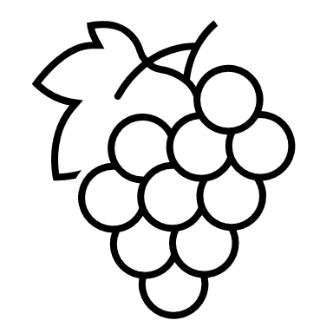
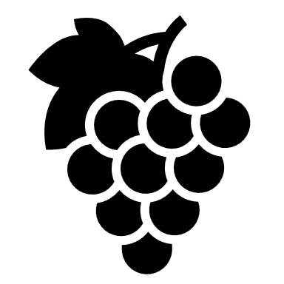
Viticulture

Lesson Plans
Grapes in the Classroom |
https://www.grapesfromcalifornia.com/community-outreach/grapes-in-the-classroom/
Grape and Wine Production |
https://extension.psu.edu/food-safety-and-quality/grape-and-wine-production
What Is Viticulture |
https://www.masterclass.com/articles/what-is-viticulture-winegrowing-learn-about-the-history-of-viticulture

Websites

PA Wine | https://pennsylvaniawine.com/wine-trails/
This website lists the local wineries in Pennsylvania to promote the states viticulture.

Berks County Wine Trail | http://www.berkscountywinetrail.com/
This website lists the local wineries in Berks County specifically and promotes the viticulture locally.

