Tones Chart
Symptom | Possible Cause/Solution
Busy Tones | You cannot transmit because all channels are busy, release PTT and wait for call-back.
Three short high pitched tones | Talk Permit. You can now continue with your requested transmission.
Continuous low-pitched tone when pressing the PTT button | Indicates you are out of range, or system is out of service, or the channel is busy with Smart PTT enabled.

Scan List Program
To add a talkgroup/ channel:
- Press the 4-way Navigation button until SCAN is displayed.
- Press and hold the button below SCAN
Indicator flashes, indicating the
Program/View mode. You will also see
SEL, DEL, and RCL displayed as possible
choices.
3. Press either side of the 4-way navigation button to scroll through the available zones and/or turn the talkgroup/channel select knob to scroll through the talkgroups/channels within each zone.
- When you reach a talkgroup/channel that you wish to add to the scan list, press the button below SEL to add the talkgroup/channel to the scan list.
The scan indicator ( ) is displayed indicating that the talkgroup/channel is a member of the scan list.
- Press the HOME button to exit scan list programming and return to normal operation.
To delete a talkgroup/channel:
1. Press and hold the softkey below SCAN.
- Repeatedly press the button below RCL to scroll through the scan list members.
- When you reach a talkgroup/channel that you wish to delete from the scan list, press the button below DEL to delete the talkgroup/channel from the scan list.
- The scan indicator disappears indicating that the talkgroup/channel is no longer a member of the scan list.
- Press the HOME button to exit scan list programming and return to normal operation.

Print Date: July 30, 2026
Turn On/Off Display Light
- Press the Display Light button to turn on the display light. The light will go off automatically.
- Or to turn the light off manually, press the Display Light button again.



APX6500 Model O5

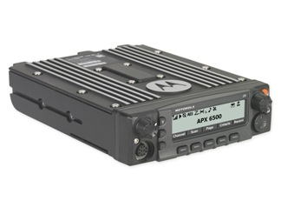

Quick
Reference
Card

To Turn Scan On/Off
- Press the 4-Way Navigation button until SCAN appears.
- Press and release the button below SCAN to start scanning.
- The Scan indicator ( ) lights and a list of talkgroups/channels are scanned for activity.
- To turn off scan, press the button below SCAN again to turn scan off. The scan indicator disappears.

Nuisance Delete
Temporarily delete a talkgroup/channel from
scan list. When the radio is locked onto the
talkgroup/ channel to be deleted:
1. Press the Menu Select button directly below NUIS.
2. Press the Menu Select button directly below DELETE.
Restoring a Nuisance Channel/Talkgroup
Turn Scan off and then on, turn radio off and then on, or change modes.

Emergency – Trunked Feature
- With the radio turned on, press the emergency button.
The LED lights solid red, the display
alternates between showing
“EMERGENCY” and the current trunked
zone and talkgroup/channel, and a short, medium-pitched emergency tone sounds.
2. Press the PTT button and announce your emergency.
3. Release the PTT button to end the transmission and wait for a response from
the dispatcher.
- To exit emergency: Press and hold the Emergency button for about one second.
The radio user should NEVER clear the emergency on their radio without being instructed to do so by dispatch.

Display Intensity
To adjust the display brightness, press the
Dim button until the desired intensity is displayed.

Changing Background Colors –
- Press 4-Way Navigation button until
COLR is displayed.
- Press the menu select button below
COLR.
- Press navigation button to scroll
through the available colors
(RED, GREEN, AMBER).
- Press menu select button below
SEL to select the desired color.

APX6500 Model O5
Turn Radio On/Off
- Press the Power button on the control unit once to turn it on.
- Press the Power button again to turn the unit off.
Volume Set
- Rotate the Volume Control Knob clockwise to increase volume, counterclockwise to decrease volume.
Select a Zone and a Talkgroup/Channel
To Select a Zone:
- Press the left or right side of the 4-Way Navigation button until ZONE appears on the display.
- Press the softkey below ZONE.
The current zone name flashes on the display.
- Press the 4-Way Navigation keys until the desired zone name appears on the display.
To Select a Talkgroup/Channel:
- To select a talkgroup/channel, turn the Channel Knob until the desired talkgroup/channel name is displayed.
- Press the PTT button to begin transmitting on the displayed zone and talkgroup/channel.

Select the HOME Talkgroup/Channel
Press and hold the HOME Button.

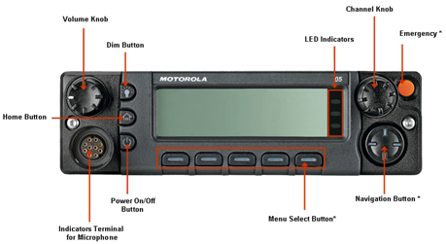
_{Menu Select Items}
Nuis Prfl Zone Scan ScnL
Mute Info Rcnt Colr Cnts
_{Myid}
_{Menu Select Items}
Nuis Prfl Zone Scan ScnL
Mute Info Rcnt Colr Cnts
_{Myid}

