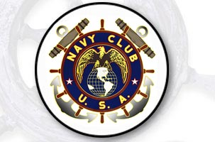
NCUSA National Asso. | Website | http://www.navyclubusa.org/
Local, Ship 258 | e-mail | NCUSA.Ship258@Gmail.com
Who is welcome: | Any active duty or former Navy, Marine Corps or Coast Guardsman with an honorable discharge.
Meetings: | 7:30 PM LAST Tuesday of each month  Wyomissing Public Library  9 Reading Blvd., Wyomissing  (1 block West of Vanity Fair)
Purpose and Preamble to our Constitution:
In reverent recognition of Divine Guidance, we associate ourselves, pledging ourselves to maintain true allegiance to the government of these United States of America and fidelity to its Constitution and Laws.
The objects of this Association are to further, encourage, promote, and maintain comradeship among our members, to revere, honor, and perpetuate the memory of our departed shipmates; and to promote and encourage further public interest in the United States Navy and its history and to uphold the spirit and ideals of our Navy.

